**Practical No.:-**

**Aim:- Configure Ethernet/Fast Ethernet Interface**

**Take Following Components.**

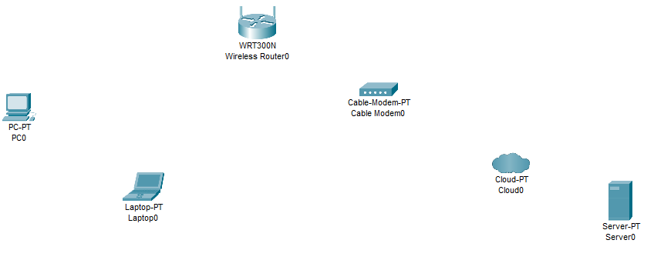

**Click on Laptop0🡪Off the switch then remove component and drag wireless component🡪on switch.**

**Connection is Established between wireless router and Laptop**.

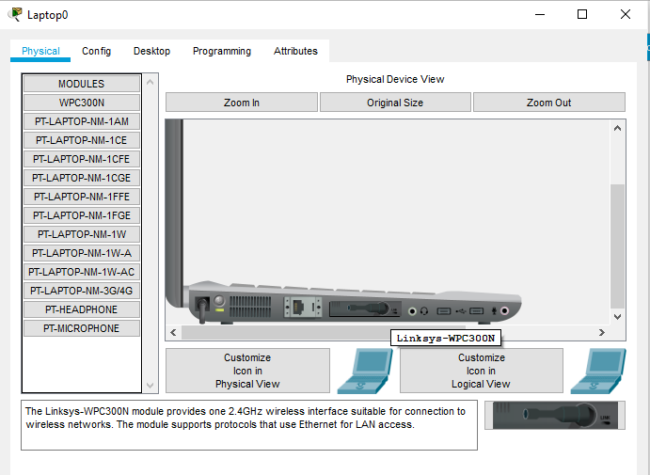

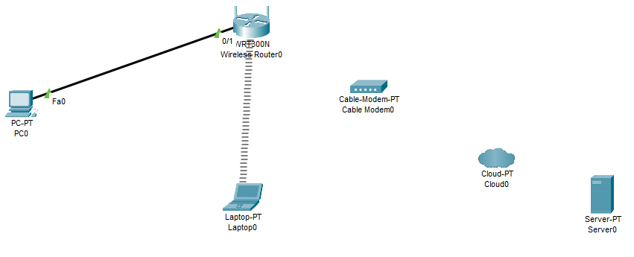

**Established Connection as shown below**

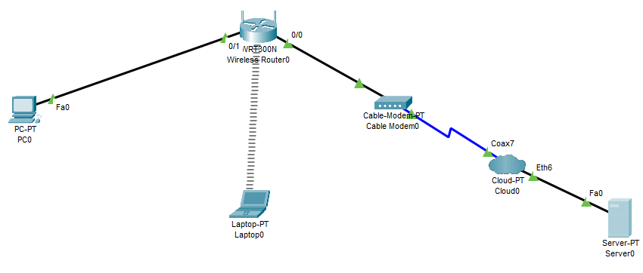

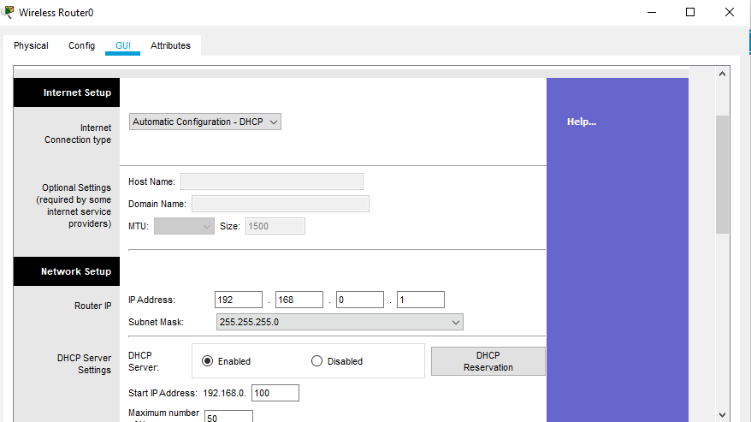

**Click on DHCP 🡪IP Address will automatically display**

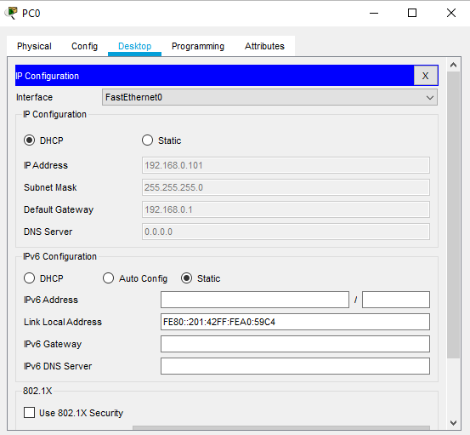

**Click on DHCP 🡪IP Address will automatically display**

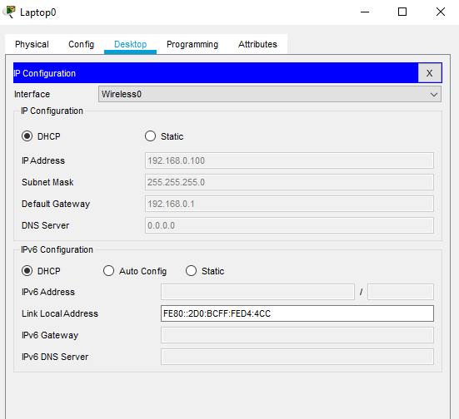

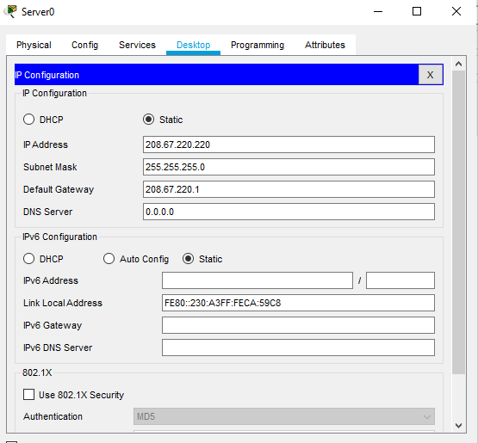

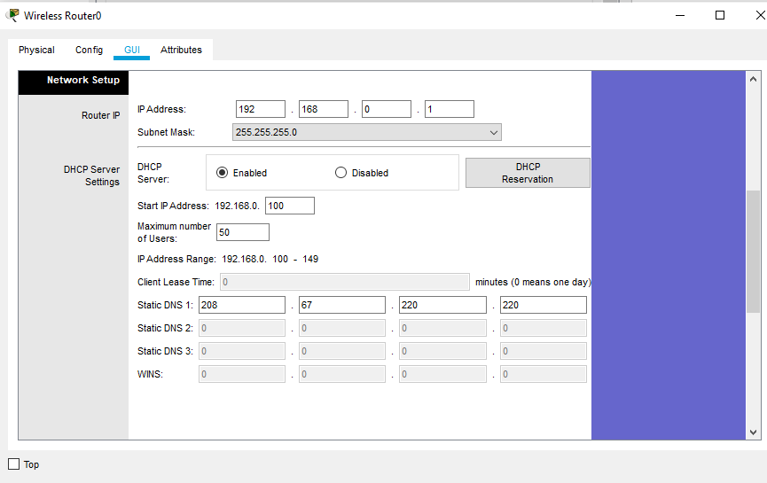

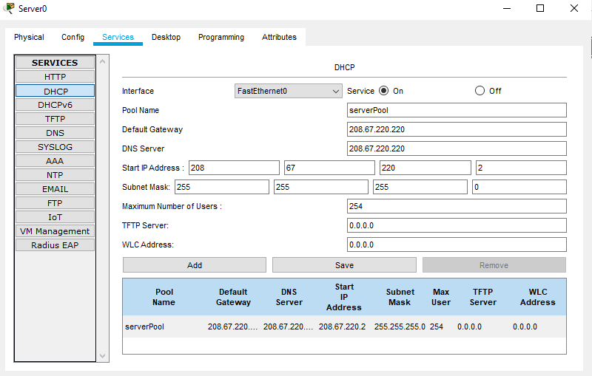

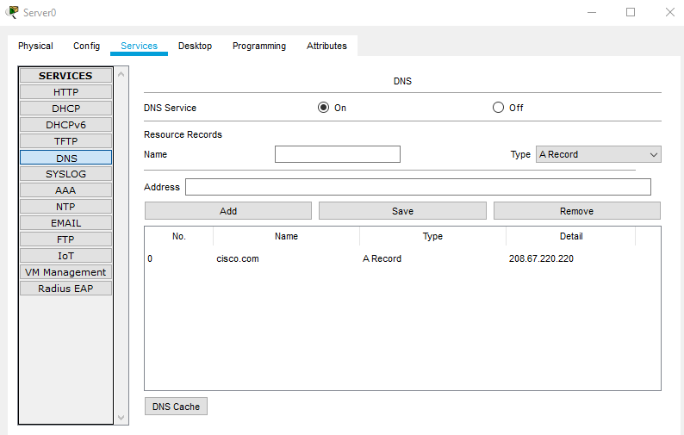

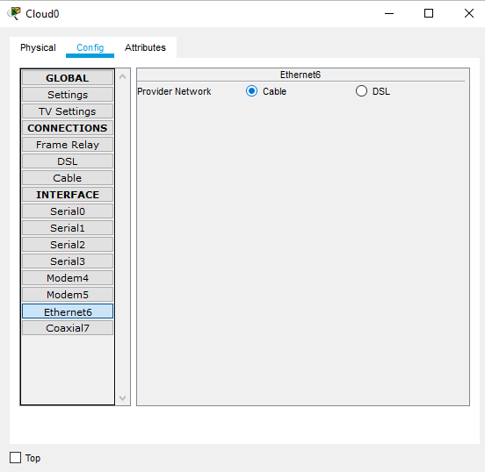

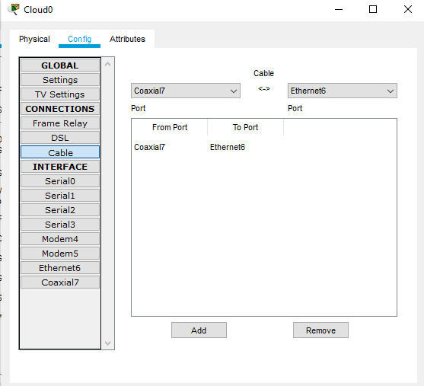

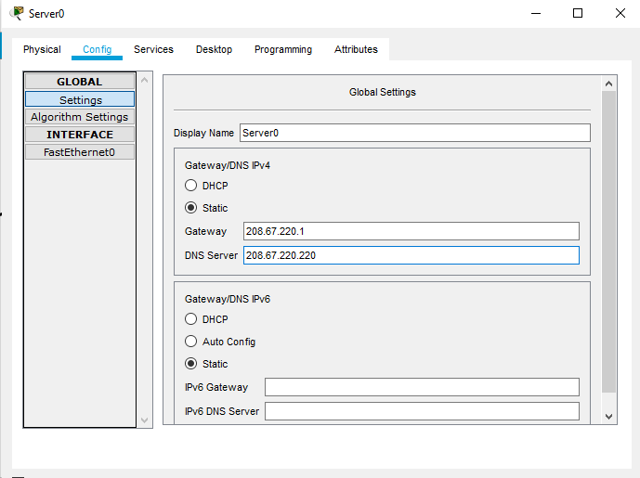

**Go to🡪PC0🡪Desktop🡪Command Prompt**

Packet Tracer PC Command Line 1.0

C:\>ipconfig

FastEthernet0 Connection:(default port)

Link-local IPv6 Address.........: FE80::201:42FF:FEA0:59C4

IP Address......................: 192.168.0.101

Subnet Mask.....................: 255.255.255.0

Default Gateway.................: 192.168.0.1

Bluetooth Connection:

Link-local IPv6 Address.........: ::

IP Address......................: 0.0.0.0

Subnet Mask.....................: 0.0.0.0

Default Gateway.................: 0.0.0.0

C:\>ipconfig /release

IP Address......................: 0.0.0.0

Subnet Mask.....................: 0.0.0.0

Default Gateway.................: 0.0.0.0

DNS Server......................: 0.0.0.0

C:\>ipconfig /renev

Invalid Command.

C:\>ipconfig /renew

IP Address......................: 192.168.0.101

Subnet Mask.....................: 255.255.255.0

Default Gateway.................: 192.168.0.1

DNS Server......................: 208.67.220.220

C:\>ping 208.67.220.220

Pinging 208.67.220.220 with 32 bytes of data:

Request timed out.

Reply from 208.67.220.220: bytes=32 time=1ms TTL=127

Reply from 208.67.220.220: bytes=32 time=1ms TTL=127

Reply from 208.67.220.220: bytes=32 time=1ms TTL=127

Ping statistics for 208.67.220.220:

Packets: Sent = 4, Received = 3, Lost = 1 (25% loss),

Approximate round trip times in milli-seconds:

Minimum = 1ms, Maximum = 1ms, Average = 1ms

C:\>ping 208.67.220.220

Pinging 208.67.220.220 with 32 bytes of data:

Reply from 208.67.220.220: bytes=32 time=2ms TTL=127

Reply from 208.67.220.220: bytes=32 time=1ms TTL=127

Reply from 208.67.220.220: bytes=32 time=1ms TTL=127

Reply from 208.67.220.220: bytes=32 time=2ms TTL=127

Ping statistics for 208.67.220.220:

Packets: Sent = 4, Received = 4, Lost = 0 (0% loss),

Approximate round trip times in milli-seconds:

Minimum = 1ms, Maximum = 2ms, Average = 1ms

Finish